IDD Training Guidelines
Note : That give attention to laptop before half an hour & download the zip file, as the runtime can get disconnected if it is used for prolonged amount of time.
- Connect Laptop Charger & Keep it connected and powered on throughout the training.

- Connect to Stable Low Traffic Wi-Fi Connection.

- Go into Settings then


Click on Power Mode Option

Choose Best performance for both plugged in & on battery
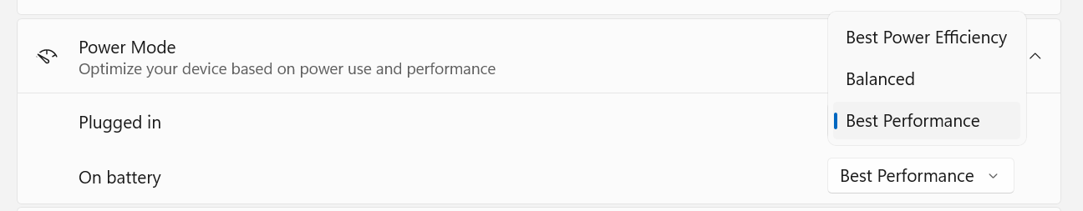

After that, Click on Screen, sleep & Hibernete timeouts

Choose Never Option for both plugged in & on Battery
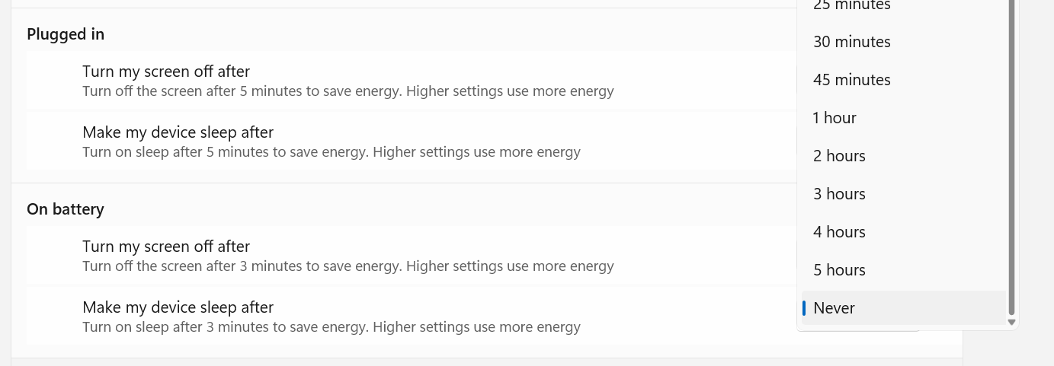

- After that Search “Screen Saver” in search bar
Choose None option & click on apply button.
